|  |  |  |  |  |  |
| --- | --- | --- | --- | --- | --- |
| Date | 24-Nov-22 | | | Tester Name | Mohammad Yusuf |
| Environment | Select Environment | | | Login used |  |
| Operating System | Select OS | Version: | Update: | | |
| Software Used | Firefox | Version: | Update: | | |
| Select Software | Version: | Update: | | |
| Release version |  | | | | |
| Title | M33.04 Change Additional Tax | | | | |
| Test Type | Regression | | | | |
| Test Scenario | Change Additional Tax | | | | |
|  |  | | | | |
| Expected Results |  | | | | |
| Pass/Fail | Select | | | JIRA# | N/A |

Describe your steps with screenshots:

Person profile

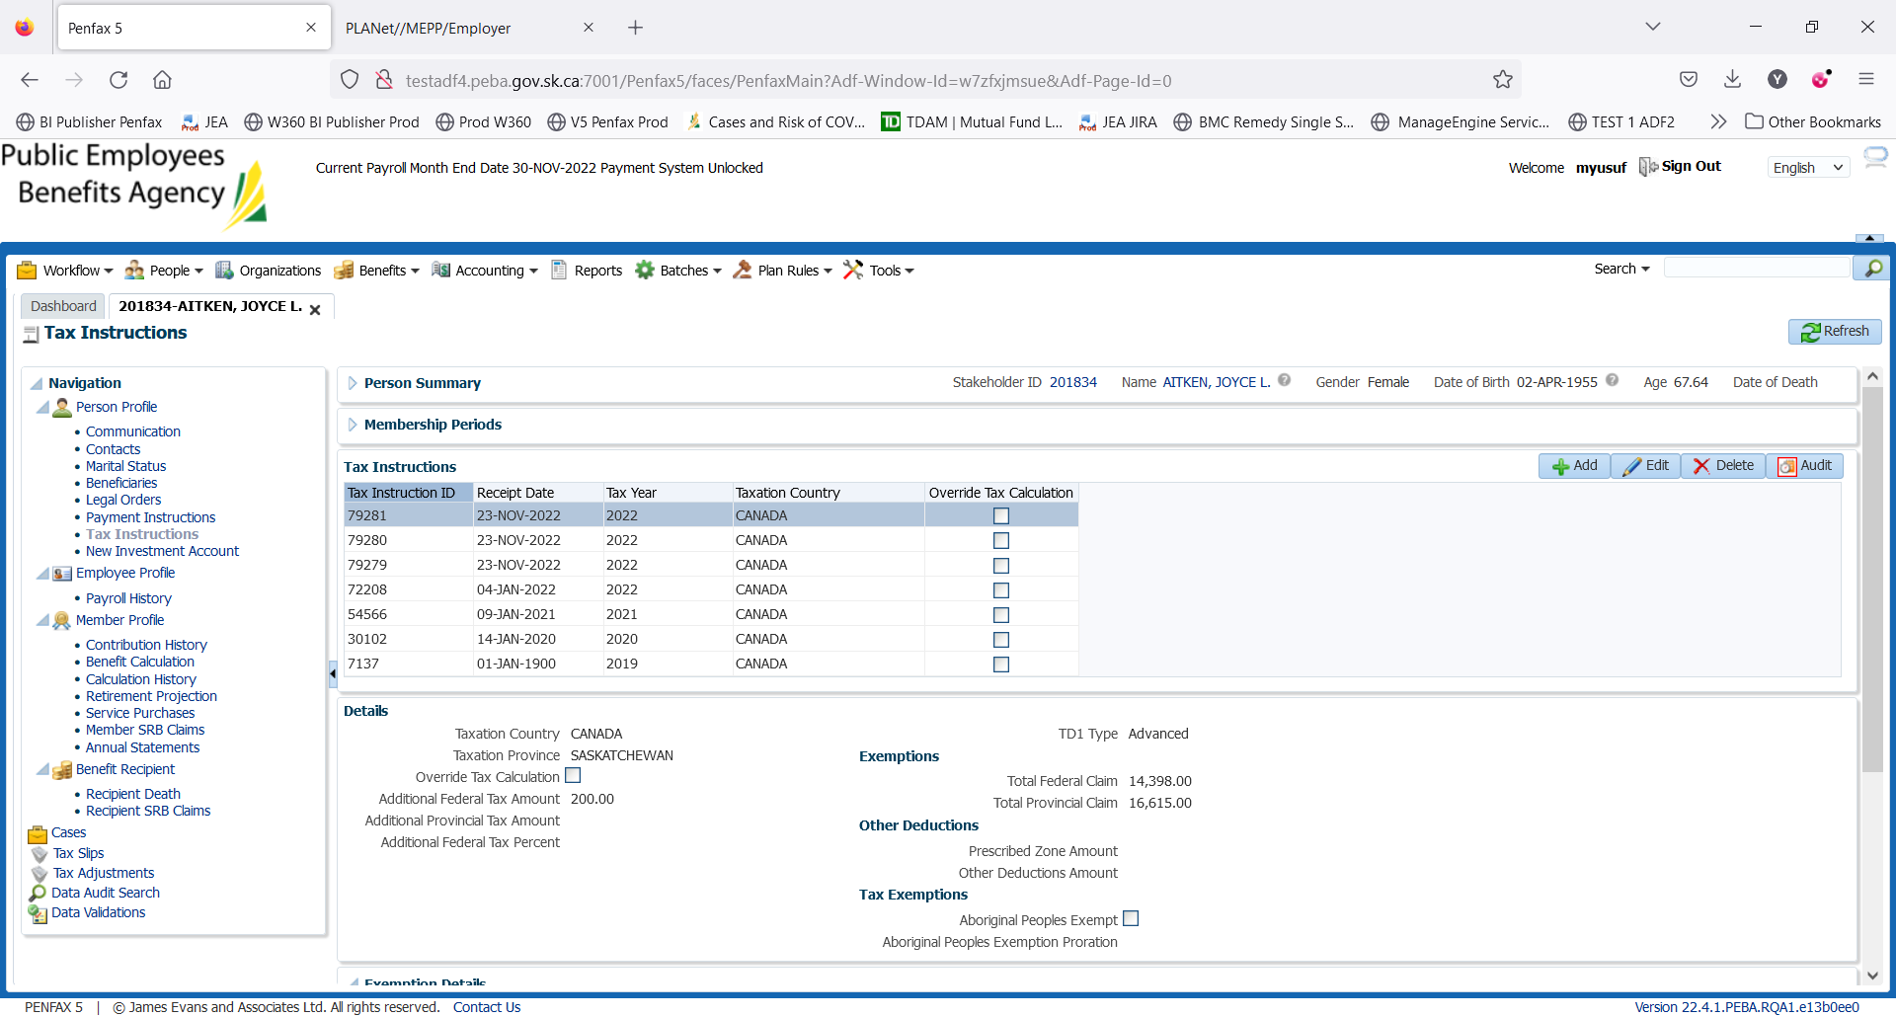

BR

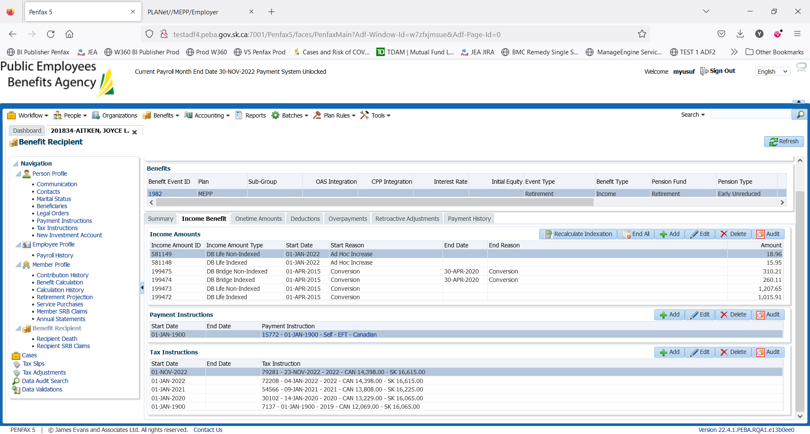

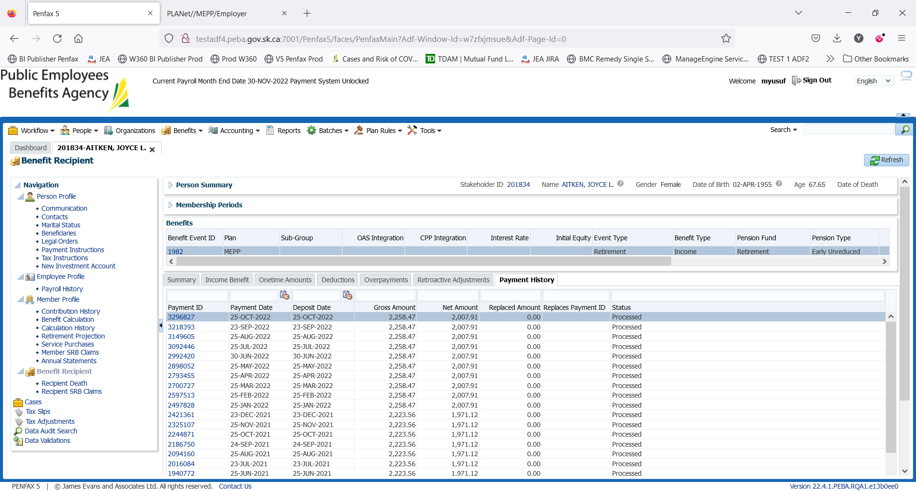

We do not have the November payment run. So you wont be able to see the Additional tax amt in Nov Payment

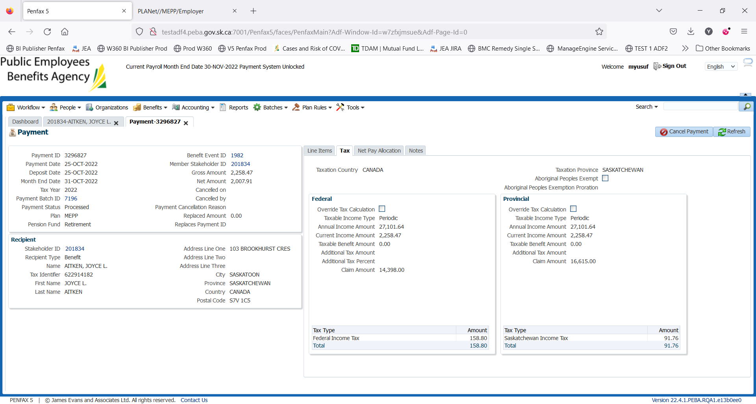

In the ideal case: The additional Tax amount should be 200 but the batch has not to be completed yet (Nov, 2022)

Change additional tax

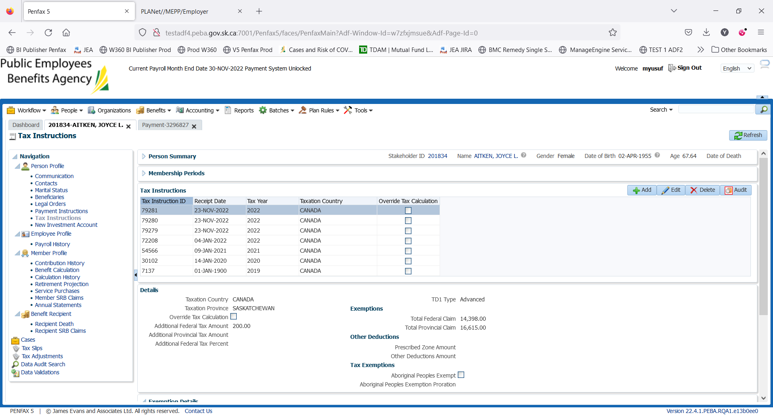

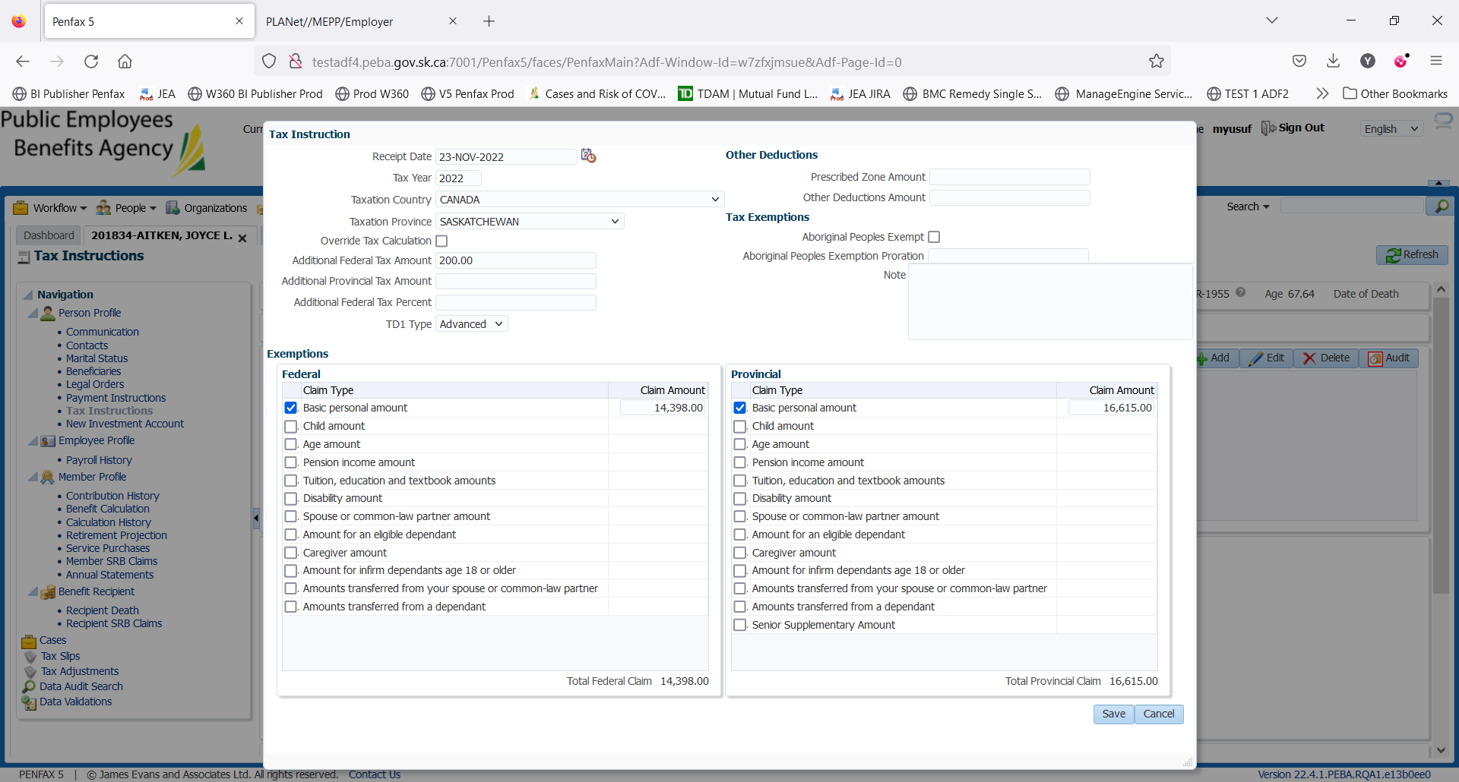

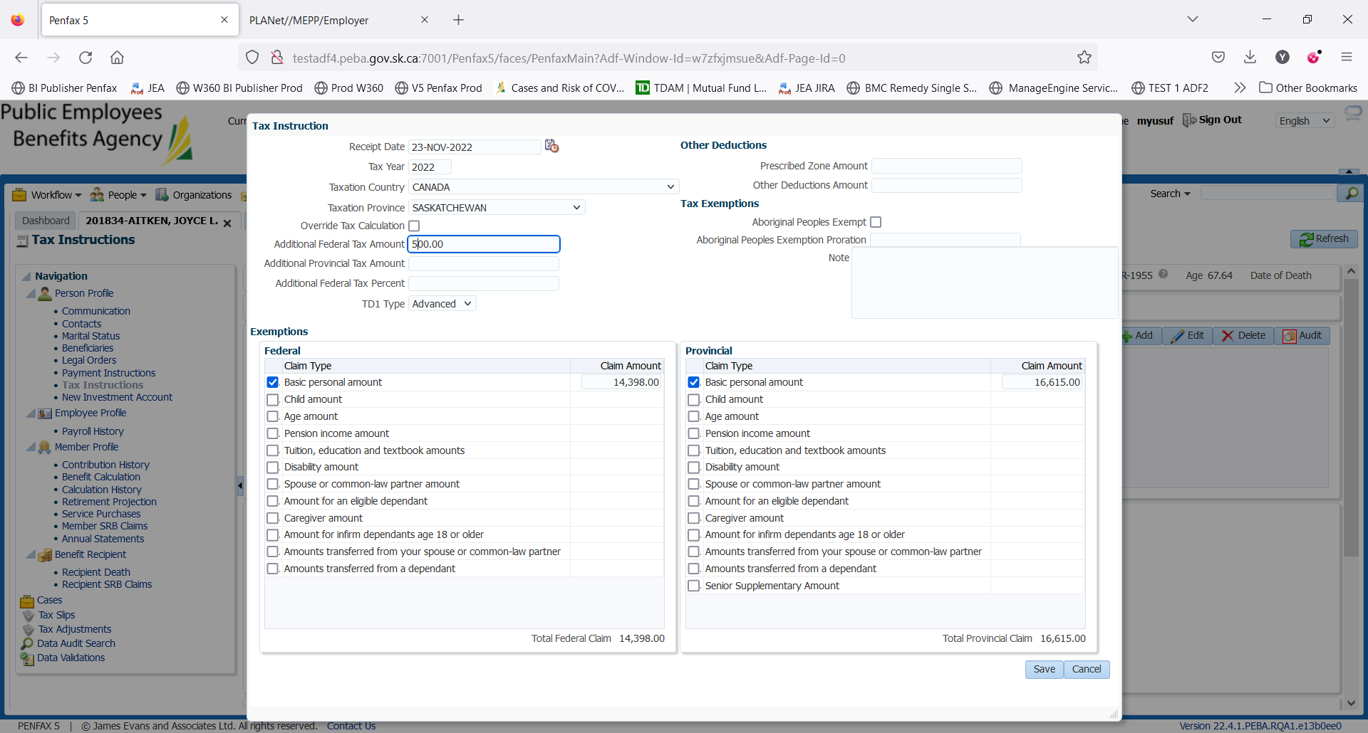

Change the amt from 200 to 500.

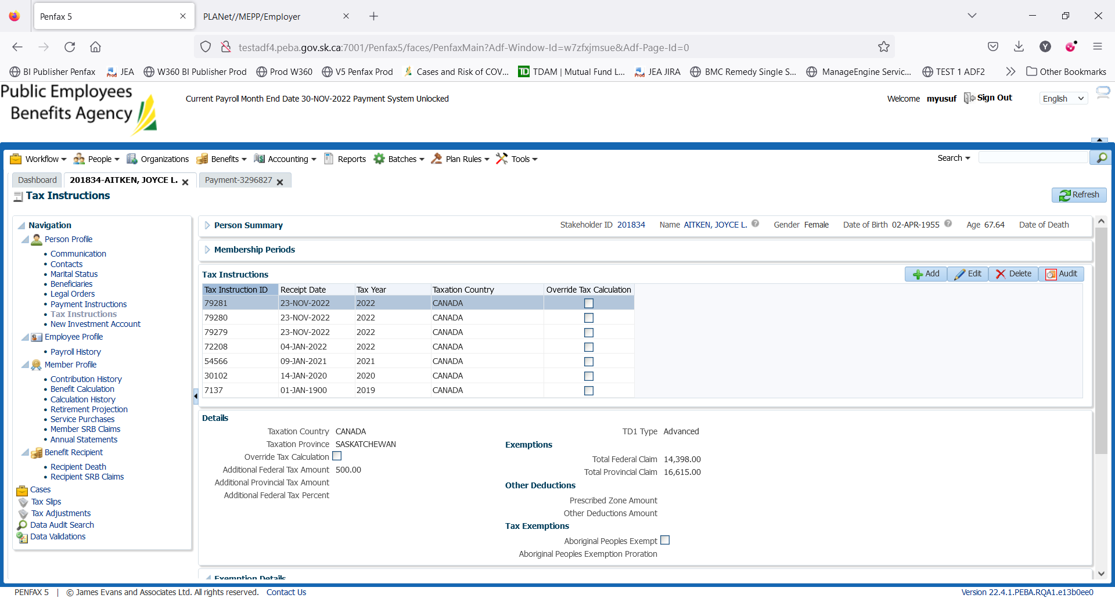

Verify the next payment after Nov Payment Batch Run 2022. The additional tax amount should be 500

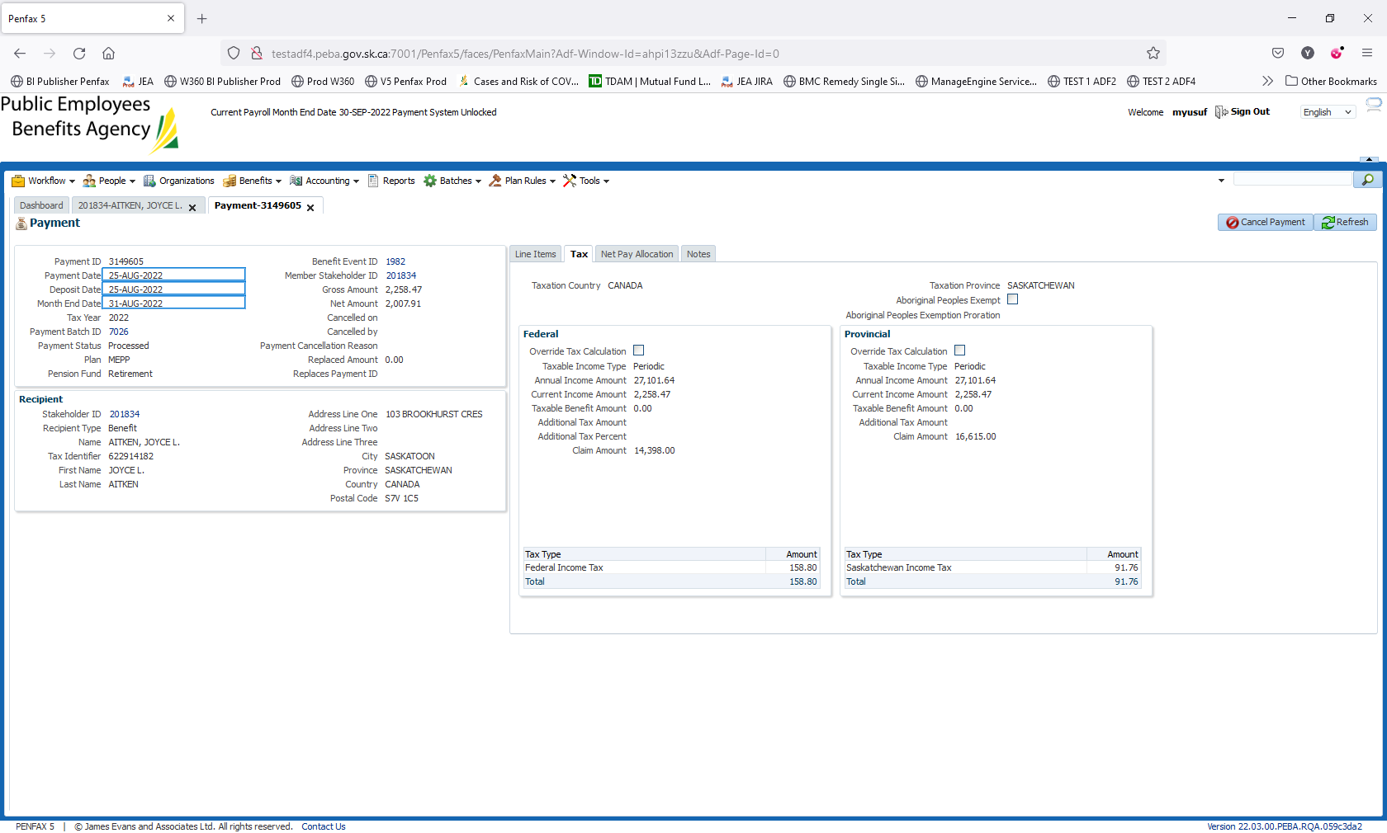

Above screenshot depicts sample payment without the Additional Tax instructions